

 **Independent Study Plan**  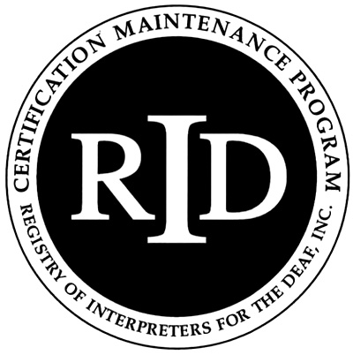

This Independent Study Activity Plan must be approved by a RID Approved Sponsor

***PRIOR*** to the onset of the activity.

Participant Name: Click here to enter text. RID Member #: Click here to enter text.

Participant’s Address: Click here to enter text.

City: Click here to enter text. State: Click here to enter text. Zip: Click here to enter text.

Email: Click here to enter text. Phone # Click here to enter text.

1. **What do I want to do?** *Describe the activity you are proposing.*

*(Ex: I would like to know more about the process of translation from a linguistic point of view. Several books on translation have been recommended. I would like to read them and apply them to my work.)*

2. **What are my specific goals?** *Keep your goals measurable, observable, and tangible.*

*(Ex: “I will compare the problems and techniques of spoken language interpreters to those I have experienced.”)*

3. **How will I show my sponsor what I learned?** *Describe your evaluation process.*

*(Ex: I will write a 1-2 page report comparing spoken and signed translation work.)*

4. **How many CEUs am I proposing and why?** *Remember, in an educational setting, 10 contact hours = 1 CEU. Non-traditional activities should follow a different ratio, which is outlined in the Standards & Criteria. A maximum of 2.0 CEUs can be earned for each project. (Larger projects may be broken into components and each component filed as a separate independent study project earning up to 2.0 CEUs each.)*

**5. When will this proposed project start and end?** *Project must be completed within twelve months.*

**6. To which *content area* does this independent study apply?**

Professional Studies or General Studies *(Check one)*

I agree to implement the Independent Study Activity as outlined in this plan and to submit all the necessary documentation of successful completion to my Sponsor. I certify that this activity for CEU credit represents a valid and verifiable Continuing Education Experience that exceeds routine employment responsibilities.

Click here to enter a date. Click here to enter text.­­­

**Participant’s Signature** **Date** **Participant’s Name (print)**

I will insure that this Independent Study Activity will be overseen and evaluated by individual(s) with the relevant expertise. I, or my designee, have discussed the Independent Study Activity outlined in this plan with the participant and agree that it represents a valid and verifiable Continuing Education Experience. Further, I or my designee, agree to assess the documentation submitted to me by the participant upon completion of the Independent Study Activity and award Click here to enter text. CEUs if completion is satisfactory.

Click here to enter a date. Click here to enter text.

**Sponsor’s Administrator Signature**   **Date**  **Sponsor’s Administrator Name (print)**

**Updated March 2016**